1st 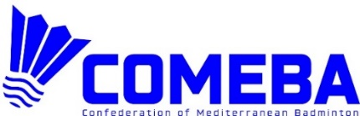 AirBADMINTON
CHAMPIONSHIP 2024
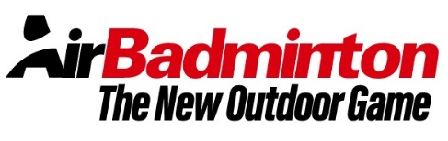
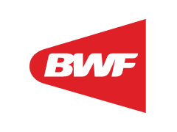 CROATIA, Adriatic sea, Ičići, Beach Ičići, 24 August

Entry form
Send to: | Croatian Badminton Association / Badmintonski klub Stella  Remetinečka 77a, 10000 Zagreb, Croatia  e-mail: info@crointer.com  mob: +385 91 72 71 302
Closing date: | 15 August 2024
National Association, club or team marketing name

Responsible person/contact
Mobitel or email

DOUBLES TEAM | Nr | Players | Women, men
 | 1.
 | 2.

TRIPLES TEAM | Nr | Players | Women, men
 | 1.
 | 2.
 | 3.

